**Department of Electrical Engineering**

|  |  |
| --- | --- |
| **Faculty Member: Maam Huma Ghafoor** | **Dated: 2/12/2023** |
|  |  |
| **Course/Section: BEE 12** | **Semester: Spring 2023** |
|  |  |

**EE-351 Communication Systems**

# Lab1: Introduction to Analog Communications

|  |  |  |  |  |  |  |
| --- | --- | --- | --- | --- | --- | --- |
| **Name** | **Reg. No** | **Viva / Quiz / Lab Performance** | **Teamwork** | **Ethics** | **Software tool Usage** | **Analysis of data in Lab Report** |
|  |  | **5 Marks** | **5 Marks** | **5 Marks** | **5 Marks** | **5 Marks** |
| **Muhammad Ahmed Mohsin** | **333060** |  |  |  |  |  |
| **Amina Bashir** | **343489** |  |  |  |  |  |
| **Syeda Fatima Zahra** | **334379** |  |  |  |  |  |
| **Hassan Rizwan** | **335753** |  |  |  |  |  |

Table of Contents

1 Lab1: Introduction to Analog Communications 1

3 Lab Instructions 2

4 Lab Report Instructions 2

6 Lab Tasks 3

6.1 200mv/peak to peak 5

6.2 400mv/peak to peak 5

7 Conclusion 9

**Lab1: INTRODUCTION TO BASIC LABRORATORY EQUIPMENT**

**Objectives**

1. The main purpose of this lab is to learn the basic principles involved in analog communication and learn some important concepts such as recognition of message signal, carrier signal and modulated signal.
2. In addition to that this lab is also hands on experience to the software “Tie Pie Multi Channel”
3. We will also learn hardware including Analog Communication Board, F.A.C.E.T Base Unit, Power Supply Multimeter, Virtual Oscilloscope and generator.

# Lab Instructions

* The students should perform and demonstrate each lab task separately for stepwise evaluation
* Each group shall submit lab report on LMS within 6 days after lab is conducted. Lab report submitted via email will not be graded.
* Students are however encouraged to practice on their own in spare time for enhancing their skills.
* Complete as many problems as you can within the allotted time.
* Talk to your classmates for help

# Lab Report Instructions

1. All questions should be answered precisely to get maximum credit. Lab report must ensure following items:
2. Lab objective
3. Results (screen shots) duly commented and discussed.
4. Conclusion

# Lab Tasks

* Locate a AM/SSB transmitter circuit block on the Analog Communications Circuit and connect the Signal Generator to the M of Modulator. Set Switches S1, S2 and S3 to OFF.

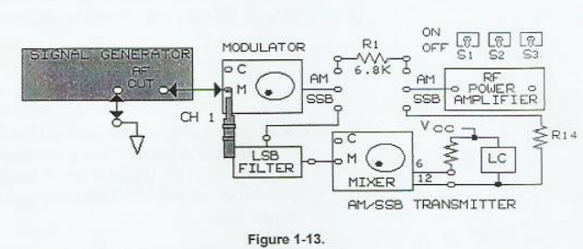

* Set Oscilloscope Channel 1 to 100mv/DIV, set the sweep to 0.2ms/DIV, then trigger on Channel 1. Set channel 1 to ac. Connect the Oscilloscope channel 1 to M of the modulator.
* While observing the signal on channel 1, of the oscilloscope, adjust the signal generator for a 200mVpk-pk. 2kHz sin wave signal at M.
* What is the Channel 1 signal at M on the modulator, the carrier signal or message signal?

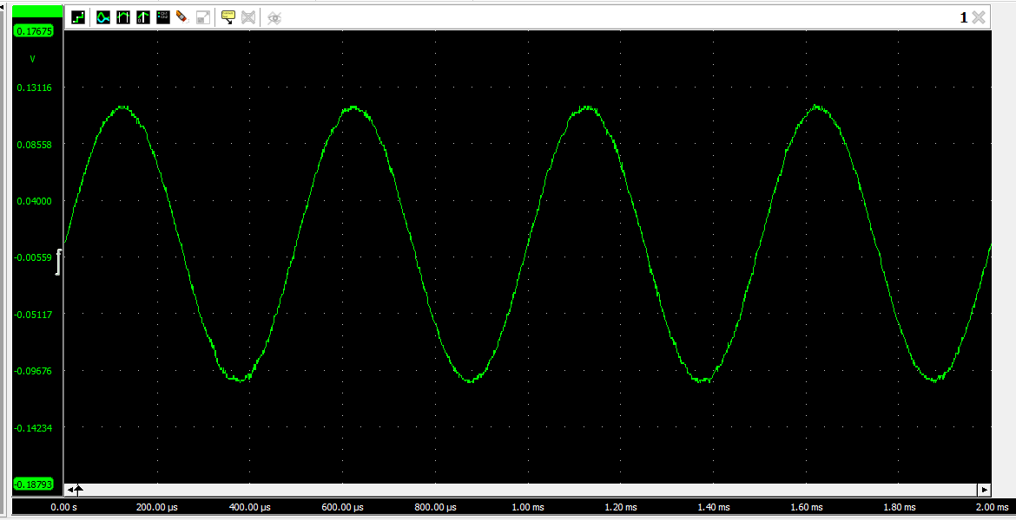

* Increase the frequency of the message signal to 5kHz, then decrease the frequency to 2khz by varying the AF frequency knob on the signal generator.

* When increase the frequency on the signal generator, did the signal period decrease?

Yes, the time period of the signal decreased when we increased the frequency to 5KHz. The new time period is given by:

T=1/f

T=1/5K

T=0.2ms

* Increase the amplitude of the message signal to 400mVpk-pk, then decrease the amplitude to 200mVpk-pk by varying the AF level Knob on the signal generator.
* When you increased the amplitude of the message signal to 400mVpk-pk, did the period increase, decrease or stay constant.

## 200mv/peak to peak

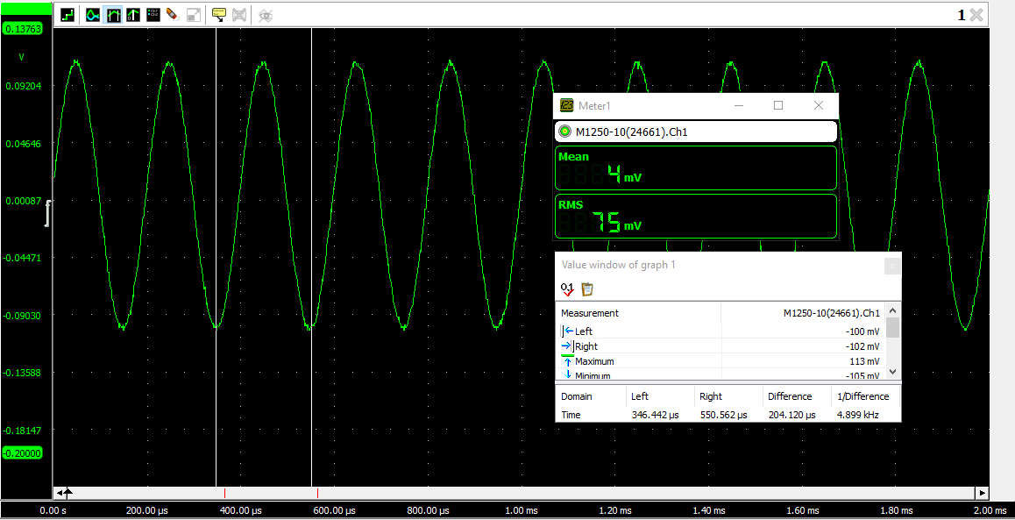

## 400mv/peak to peak

* Locate the VCO-LO Circuit block on the Analog Communications board. Place a two port connector in the 1000kHz position on VCO-LO circuit. Connect OUT on the VCO-LO circuit block to C at the modulator.

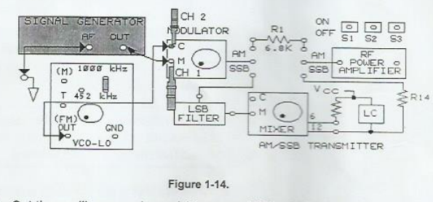

* Set the Oscilloscope channel 2 to ac and 100mv/DIV.S Set the vertical mode to ALT, then sweep to 0.5us/DIV, Trigger on channel 2, Connect the channel 2 probe to C
* While observing the signal on channel 2, set the amplitude of the VCO-LO output to 200mVpk-pk by adjusting the potentiometer knob on the VCO-LO circuit block.

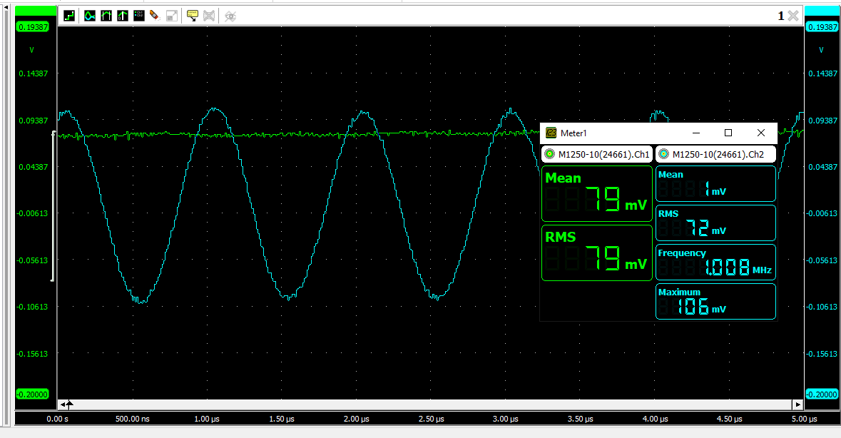

* Set the frequency of the circuit block to 1000kHz by adjusting the negative supply on the base unit. With the sweep set to 0.5us/DIV, each cycle of 1000kz signal covers two horizontal oscilloscope divisions.
* What is the signal on channel 2, message signal or carrier signal.

The signal on channel 2 is the carrier wsignal with a frequency greater than the message signal.

* Adjust the potentiometer knob completely counterclockwise, Trigger the oscilloscope on channel 1. Set the sweep to 0.2ms/DIV. and set the channel to 2 to 1 V/DIV. Connect the channel 2 probe to output of the modulator.
* Slowly turn the knob of modulator so that AM waveform on oscilloscope channel 2 appears.
* What type of modulation you are observing?

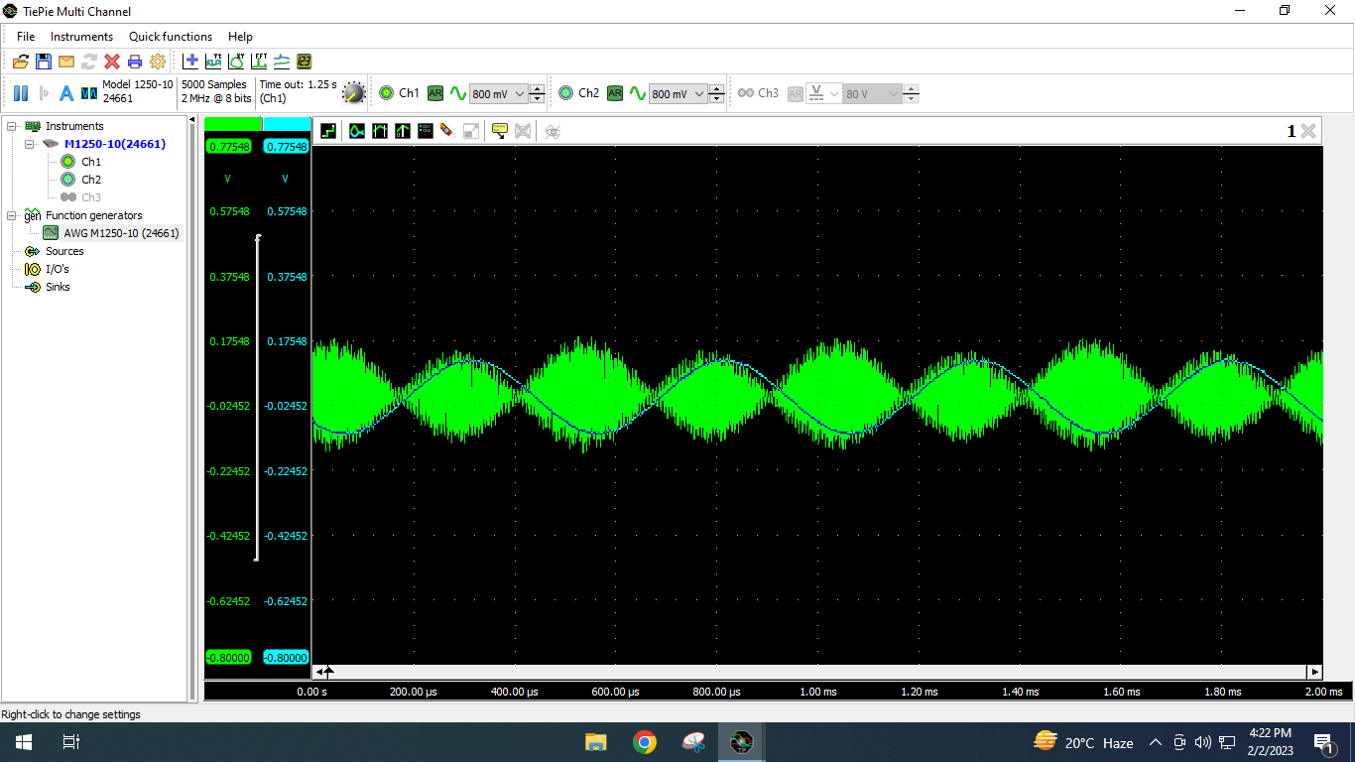We are observing amplitude modulation. In this type of modulation the carrier signals and the message signal amplitude modulates.

* Connect the modulator to power amplifier, Connect the output of power amplifier the input of Envelope Detector on receiver circuit block.
* Set the oscilloscope channel 2 to 500mv/DIV. Connect the channel 2 probe to the output of the envelope detector.
* Compare the message signal input to the modulator on channel 1 to the output of the envelope detector on channel 2.
* What the signal on channel 2, carrier signal or recovered message signal.

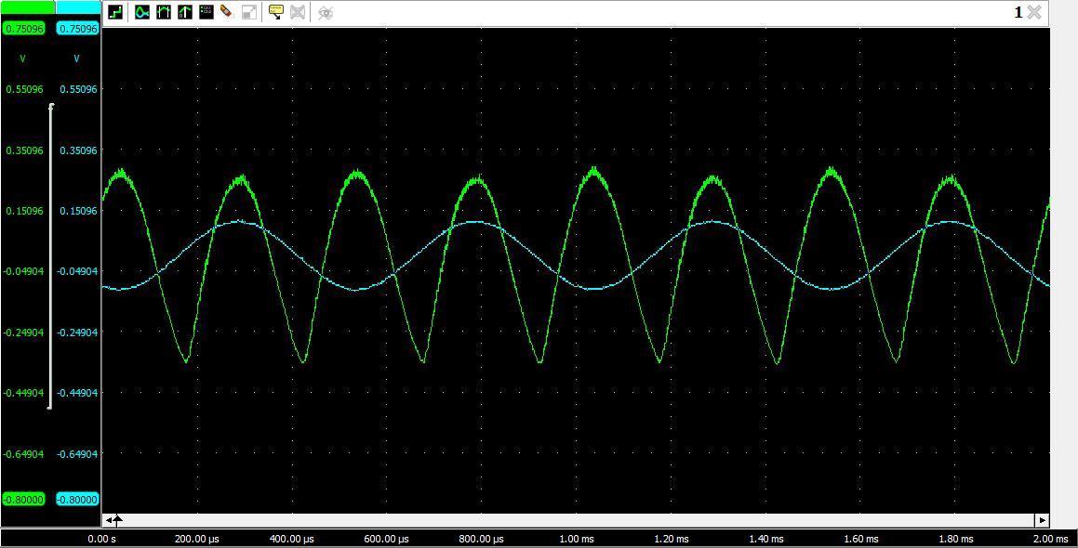

The signal we receive at the output is the message signal. It is the same as the message signal we sent through our function generator.

* On the signal generator, vary the frequency and amplitude of message signal.
* Does the amplitude and frequency of the recovered message signal on channel 2 change with the channel 1 message signal.

The amplitude of the recovered signal depends on the amplitude of the message signal in amplitude modulation. Hence, both of the amplitudes are interdependent.

# Conclusion

In this lab we learnt about the amplitude modulation and how we receive the message signal at the output after passing it through the filter. In this lab we learnt how to perform amplitude modulation on hardware and how to send the message signal through the function generator and multiply it with the carrier signal to perform the amplitude modulation. This lab correlated our hardware and theoretical concepts.